**Assignment -2**

|  |  |
| --- | --- |
| **Assignment Date** | 25 September 2022 |
| **Student Name** | Allan Jacob P |
| **Team ID** | PNT2022TMID00034 |
| **Maximum Marks** | 2 Marks |

1. **Create a Flask App**

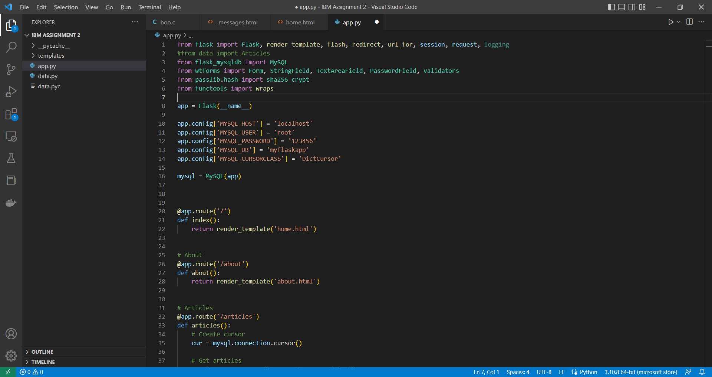

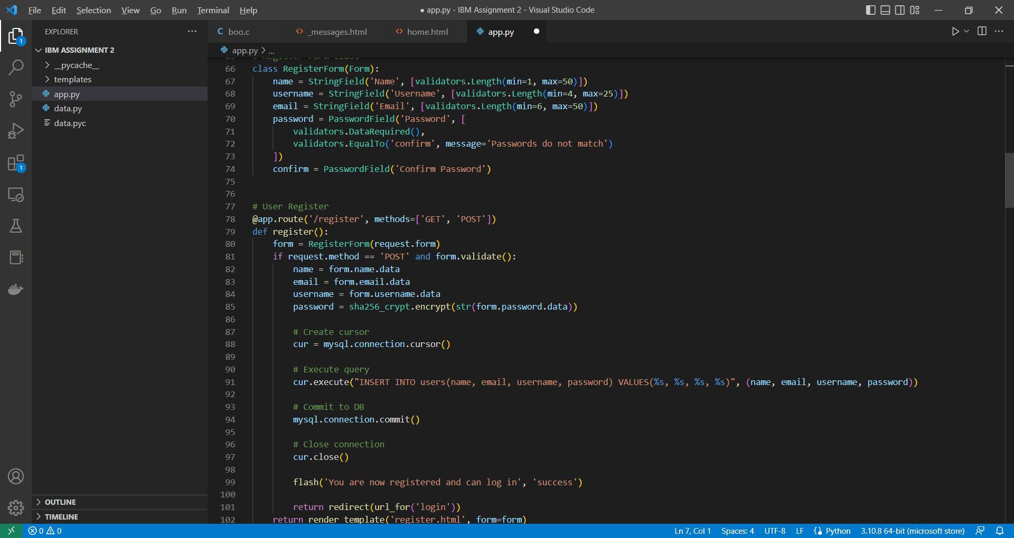

1. **Add Home Page and About Page**

***Home Page***

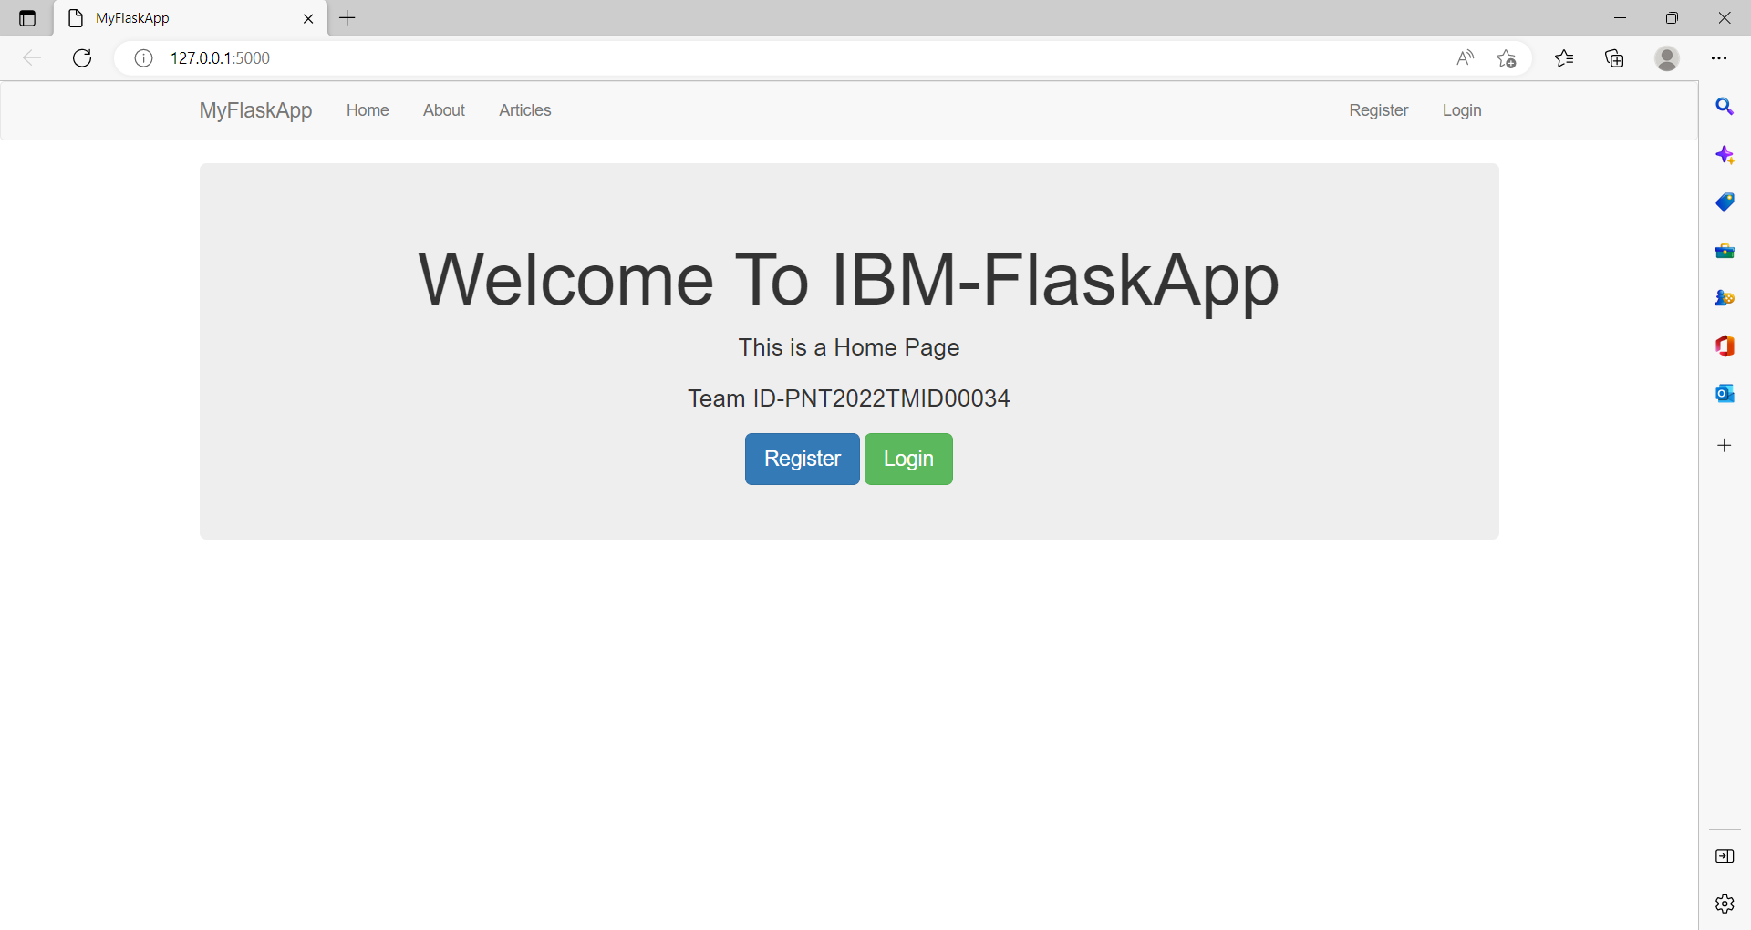

***About Page***

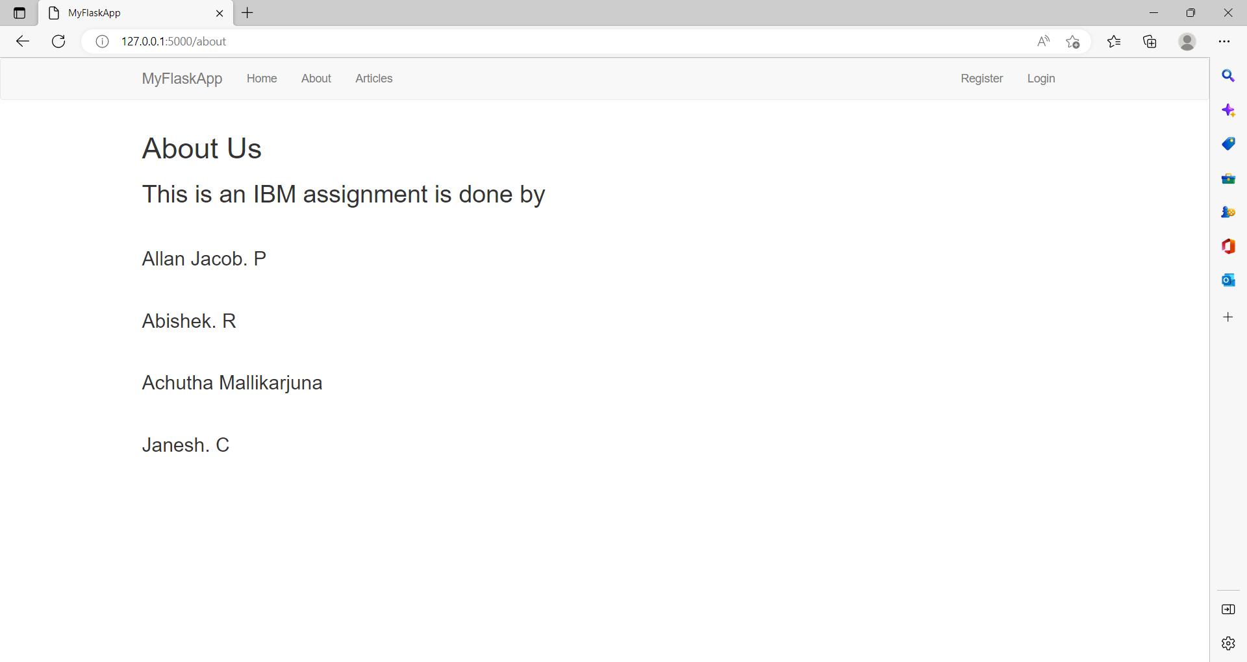

1. **Add a Bootstrap**

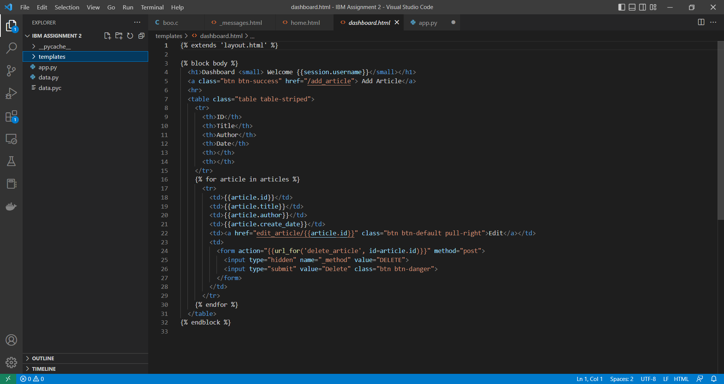

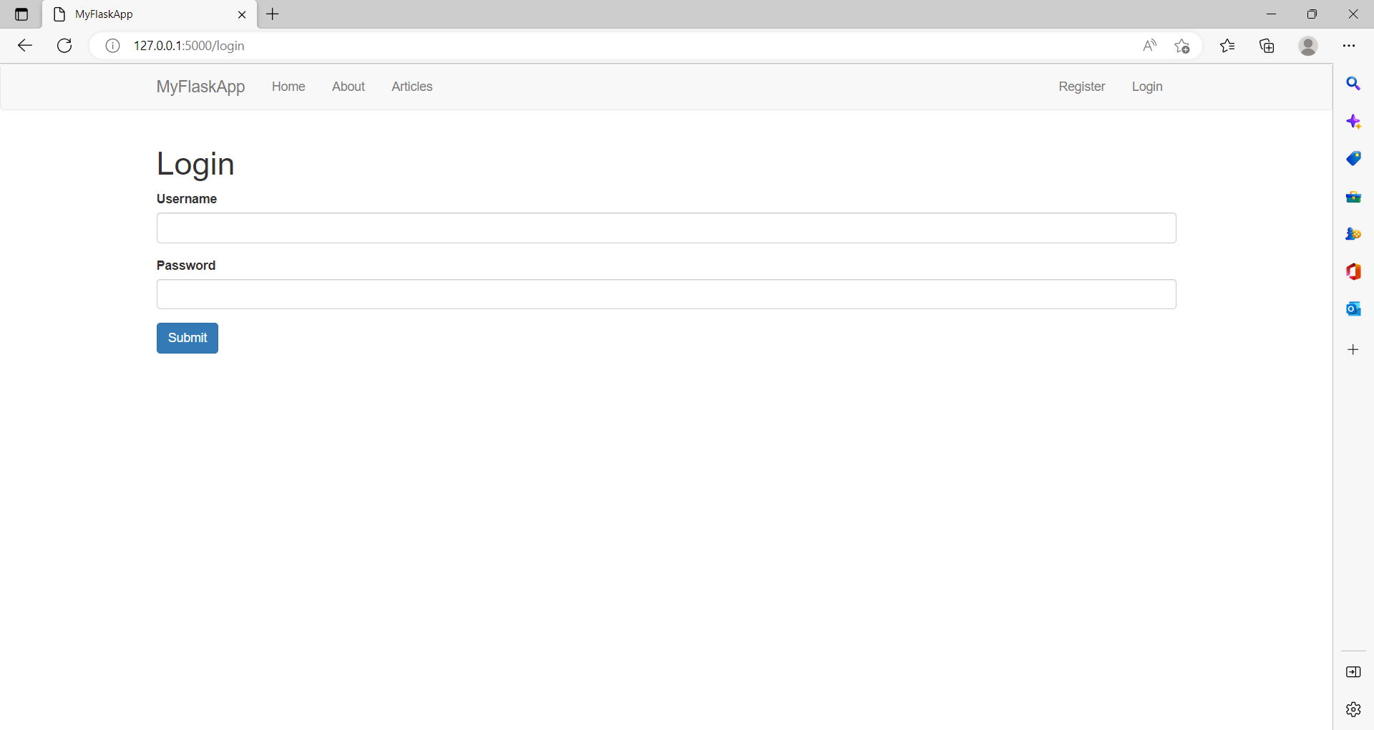

1. **Add sign -in page and database connectivity**

